**UTD Degree Planner Use Cases**

By Sanket Prabhu(srp140430)

*Use Case Documentation for UTD Degree Planner* ii

Contents

1. Context Diagram 3

2. UTD Degree Planner Actor Descriptions 4

3. UTD Degree Planner Use Cases 4

4. Use Case 1: Log In 5

5. Use Case 2: Add Course 6

6. Use Case 4: Drop Course 7

7. Use Case 5: Create User 8

8. Use Case 6: Update User 9

9. Use Case 7: Delete User 10

10. Use Case 8: Create course 11

11. Use Case 9: Update Course 12

12. Use Case 10: Delete Course 13

13. Use Case 11: Register track 14

14. Use Case 12: Create appointment 15

15. Use Case 13: Delete appointment 16

16. Use Case 14: Register appointment 17

17. Use Case 15: Cancel appointment 18

18. User Interface 18

# Context Diagram

The following figure illustrates the actors and use cases present in the application.

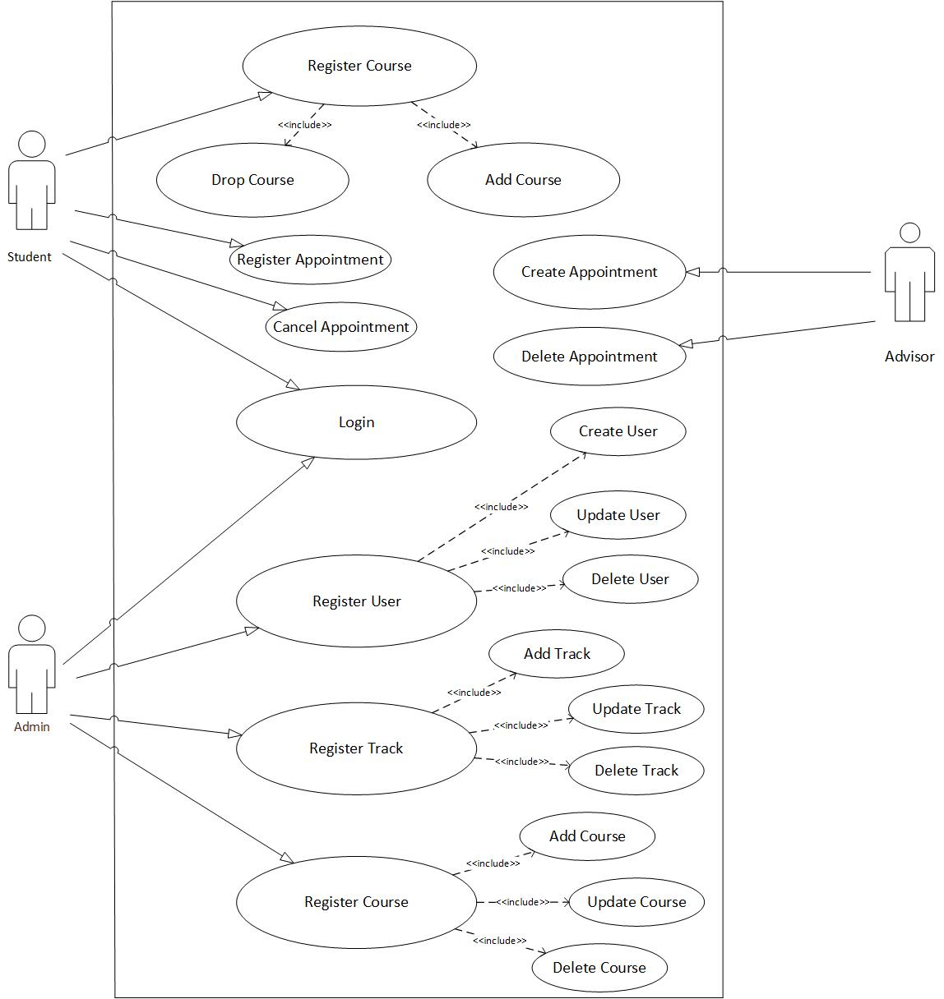

# UTD Degree Planner Actor Descriptions

1. **Student** – Enrolled student can add/drop courses using this system.
2. **Admin**– Admin manages whole system which includes add/update/delete user, courses as well as tracks.
3. **Advisor**- Advisor can create/delete advising appointment so that students can register for it.

# UTD Degree Planner Use Cases

* Log In
* Add course
* Drop course
* Create user
* Update user
* Delete user
* Create course
* Update course
* Delete course
* Register track
* Create appointment
* Delete appointment
* Register appointment
* Cancel appointment

# Use Case 1: Log In

**Actor(s)**

Student

Admin

**Description**

This is use case for login. It is used when user wishes to log in into the system.

**Preconditions**

Admin is already registered. Admin can use his credentials for login. Admin can add students and students can use same credentials for login.

**Post conditions**

If the system is authenticated with username and password, then system should redirect to their home page.

**Normal Course of Events**

* First user opens an application where this use case starts.
* User enters username and password
* If username and password is valid, system redirects it to its home page

**Alternative Courses**

* Invalid username/password
* User doesn’t exist

# Use Case 2: Add Course

**Actor(s)**

User

**Description**

User can login into his system using his credential and he can add available courses (elective and core) by clicking on add button.

**Preconditions**

To add courses user should login into his own account.

**Post conditions**

After clicking add, new courses will get added into his account.

**Normal Course of Events**

* User 1st login into his own account
* User selects courses using check boxes according to his degree plan
* User after selecting courses clicks add button to register for those courses.

# Use Case 3: Drop Course

**Actor(s)**

User

**Description**

This use case begins when user wants to drop courses for which he has registered previously.

**Preconditions**

User should be logged in into his system to successfully drop courses.

**Post conditions**

If this use case was successful, one or more courses will get dropped.

**Normal Course of Events**

* Use case begins when user needs to drop courses for which he has registered
* After login, user can check courses
* User can click on drop button to drop them successfully.

# Use Case 4: Create User

**Actor(s)**

admin

**Description**

Admin can create user by putting user information such as first name, last name, email id, UTD id, net id etc.

**Preconditions**

To add user admin should log in into his account.

**Post conditions**

After filling all required information and by clicking on add user button, new user should get created.

**Normal Course of Events**

* Use case begins when admin logs into his account
* Admin fills all information requires to create user
* Admin clicks add user to create user

# Use Case 5: Update User

**Actor(s)**

admin

**Description**

This use case begins when admin updates user information.

**Preconditions**

To update user information, admin should be logged in into his account.

**Post conditions**

By putting information which has to be updated and by pressing update button, information gets updated.

**Normal Course of Events**

* Use case begins when admin logs into his account
* Admin fills the information which he has to update and click on update button.

# Use Case 6: Delete User

**Actor(s)**

Admin

**Description**

This use case begins when admin deletes user.

**Preconditions**

Admin should be logged in into his account to perform this operation.

**Post conditions**

If the use case was successful, the selected user should get deleted.

**Normal Course of Events**

* Admin log in into his system
* Admin puts primary key of user to delete particular user
* After putting delete button user should get deleted.

# Use Case 7: Create course

**Actor(s)**

admin

**Description**

Admin can create course by putting course information such as Prefix, course name, course number, prerequisite, description etc.

**Preconditions**

To add course, admin should log in into his account.

**Post conditions**

After filling all required information and by clicking on add course button, new course should get created.

**Normal Course of Events**

* Admin logs into his account.
* Admin fills all information requires to create course.
* Admin clicks add course to create course.

# Use Case 8: Update Course

**Actor(s)**

admin

**Description**

This use case begins when admin updates course information.

**Preconditions**

To update course information, admin should be logged in into his account.

**Post conditions**

By putting information which has to be updated and by pressing update button, information gets updated.

**Normal Course of Events**

* Use case begins when admin logs into his account
* Admin fills the information which he has to update and click on update button.

# Use Case 9: Delete Course

**Actor(s)**

Admin

**Description**

This use case begins when admin deletes courses.

**Preconditions**

Admin should be logged in into his account to perform this operation.

**Post conditions**

If the use case was successful, the selected courses should get deleted.

**Normal Course of Events**

* Admin log in into his system
* Admin puts primary key of course to delete particular course.
* After putting delete button course should get deleted.

# Use Case 10: Register track

**Actor(s)**

Admin

**Description**

This use case begins when an administrator user wishes to add/update or delete track.

**Preconditions**

Admin should be logged in into the system.

**Post conditions**

If this case was successful, then admin should add/update/delete track information.

**Normal Course of Events**

* Admin should log in into his system
* Admin add/update/delete track information.

# Use Case 11: Create appointment

**Actor(s)**

Advisor

**Description**

This use case begins when an advisor wishes to create appointments.

**Preconditions**

Advisor should be logged in into the system.

**Post conditions**

If this case was successful, then advisor should create an appointment.

**Normal Course of Events**

* Advisor should log in into his system
* Advisor should select timings to create an appointment.

# Use Case 12: Delete appointment

**Actor(s)**

Advisor

**Description**

This use case begins when an advisor wishes to delete an appointment.

**Preconditions**

Advisor should be logged in into the system.

**Post conditions**

If this case was successful, then advisor should delete an appointment.

**Normal Course of Events**

* Advisor should log in into his system
* Advisor can select timings which has to be deleted as an advising session and delete them.

# Use Case 13: Register appointment

**Actor(s)**

Student

**Description**

This use case begins when Student wishes to register for an advising appointment.

**Preconditions**

Student should be logged in into the system.

**Post conditions**

If this case was successful, then student should register for an advising appointment.

**Normal Course of Events**

* Student should log in into his system
* Student can select timings for an advising appointment based on the availability and register for an appointment.

# Use Case 14: Cancel appointment

**Actor(s)**

Student

**Description**

This use case begins when student wishes to cancel his/her scheduled appointment with an advisor.

**Preconditions**

Student should be logged in into the system.

**Post conditions**

If this case was successful, then student should be able to cancel his/her advising appointment

**Normal Course of Events**

* Student should log in into his system
* Student has to select cancel an appointment button to cancel an appointment.

# User Interface

Degree Plan Implemented:

Track1: Data Science

Track2: Network and Telecommunication

